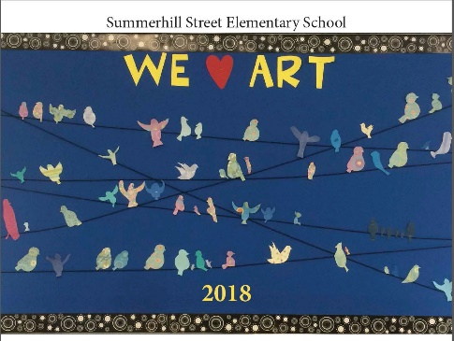
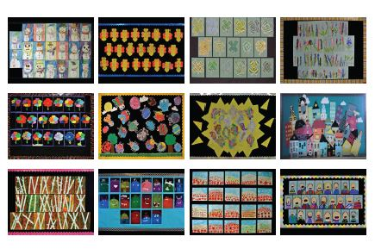

Hello Summerhill Families,
We are selling Summerhill 2018 Calendars just in time for the holidays. Each Class has taken a month of the calendar and has worked very hard on a piece of art for that particular month. Every student has a piece of art displayed in our school calendar.
Cost: $10.00 each
Please fill out the form below for customer who wish to purchase a calendar. Please make any cheques payable to Summerhill Street Elementary School. Please bring your calendar orders back to school by December 20, 2017.
Student’s Name:____________________________________ Teacher:_________________________________________
Customer’s Name | Address | Telephone | Email address | QTY | Total | Paid

